FORM 2
THE PATENTS ACT, 1970
(39 of 1970)
&
The Patents Rules, 2003
PROVISIONAL/COMPLETE SPECIFICATION
(See section 10 and rule 13)

1. TITLE OF THE INVENTION: Speak2Summarize
2. APPLICANT(S)
(a) NAME:
(b) NATIONALITY: Indian
(c) ADDRESS:. Department of Computer Science Engineering, Y.C.C.E., Hingna Road, Wanadongri, Nagpur-441110

3. PREAMBLE TO THE DESCRIPTION:

The following specification particularly describes the invention and the manner in which it is to be performed.

COMPLETE SPECIFICATION:

1. FIELD OF THE INVENTION:

This invention relates to the Machine Learning and Natural Language Processing fields concerning Speech-To-Text (STT) transformations and Text Summarization. It includes the recent techniques of Automatic Speech Recognition (ASR) in the context of deep learning architectural models and open source software . Also, it incorporates methods of summarization by use of these open source models and techniques aimed at enhancing data process automation, accessibility and content creation. The invention is useful for many sectors such as systems for transcription of protocols of meetings, automatic text summarization systems, and voice writing systems and daily voice based journaling .

2. BACKGROUND OF THE INVENTION AND PRIOR ART:

As for the natural language processing and AI technologies improve, the need for more proficient speech-to-text and text summarization increases. In the past, statistical approaches such as Hidden Markov Models and Gaussian Mixture Models were deemed effective, thus being utilized in older speech recognition systems. These systems, however, failed in dealing with accent variations and noisy background systems. The accuracy and efficiency of speech to text systems with deep learning methods has advanced with the introduction of various forms of RNNs, LSTMs and transformer architectures such as BERT and GPT. These systems now recognize speech with greater speed and precision in multiple languages and dialects.
At the same time, large volumes of spontaneously generated digital content requires advanced text summarization tools that can efficiently extract relevant information. The previously existing rule-based and statistical methods for extracting summaries of a text have slowly been transitioned to incorporate machine learning and transformer techniques which are far more capable of producing accurate and concise summaries.
The enhancement of speech to text tools through the combination of speech recognition and automated summarization has benefits for virtual assistants, meeting transcription software, podasts, content analysis, and speech accessibility applications. Multi-speaker environments, background noise, context understanding, and handling specific vocabularies still pose a challenge.
This invention seeks to address these issues through the application of advanced deep learning and NLP models aimed at improving the power and precision of speech recognition, text comprehension, and, ultimately, human-machine communication, information retrieval, and content consumption

Prior Arts:

Multi-Modal Voice Recognition System and Method for Conversation Summarization (Patent No. 18/540,594, Filed: 2024)
The patent deals with the methodologies and systems for summarizing any conversation in conjunction with multi-modality voice recognition inputs, which may include the following issues in real-time performance, bias, and sensitivity to context.

Patent No. 18/540,594 outlines a multi-modal voice recognition system designed to summarize conversations by leveraging both media (audio, video, images) and text inputs. The invention segments conversation data into media and text components, applying specialized machine learning models to each for enhanced topic modeling and key element extraction. These elements are then grouped to create concise headline banners and context-rich summaries. Particularly effective in real-time, multi-user environments like messaging platforms, the system ensures accurate, unbiased, and holistic summarization by treating all input modalities fairly and context-sensitively.

3. SUMMARY OF THE INVENTION

The system combines hardware with AI-powered software to provide an integrated Speech-to-Text (STT) function and Text Summarization System which transforms worded input into text and text into concise summaries. This is helpful for many memory-related condition suffers who can be able to review, remember, and retain useful information through well organized transcriptions and summaries.
The MAX9814 microphone captures audio, while an Arduino Nano processes the audio. The device also features a DS1302 Real-Time Clock (RTC) which time tags the audio file, and an SD card slot for archiving files. The construction of the device makes it portable with low power consumption, enabling real-world applications in assistive technology.
Speech recognition is carried out with WhisperX and text summarization is done with BERT. Combined with advanced deep learning and NLP methods, the software delivers relatively high accuracy text summary results.
This invention allows for only English language inputs and processing, making it ideal for use in virtual assistants, business, and the classroom content’s summarization. Context-aware retrieval and automatic speech recognition enable easy access and summarization of information which can be stored for future reference.
4. OBJECTIVE OF THE INVENTION:
  - To make speech-to-text and summarization tools more accessible to individuals wh are visually impaired users, professionals, students, and organizations reliable speech recognition and text based summarization of the audio.
  - To enable individuals with memory related issues to record, convert, and summarize conversations and provide a text based summary of the audio file of their daily life

5. BRIEF DESCRIPTION OF THE DRAWINGS:

- Hardware for Audio Recording
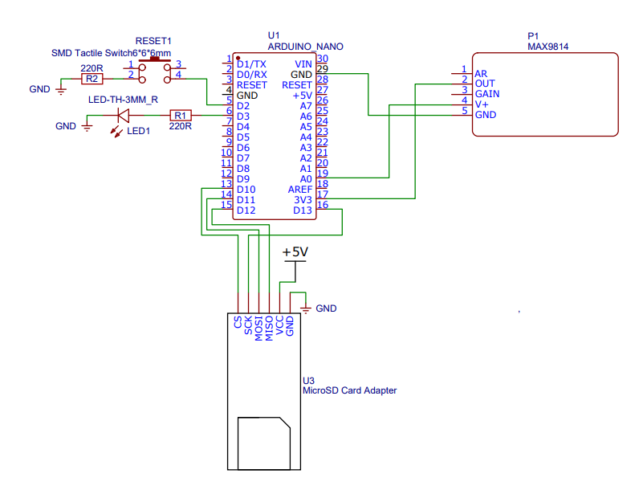
Fig 1. Circuit diagram of the audio recording apparatus

The Init, Recording, and Exit phases are the three components the system works on. During the Init Phase, the RTC is initialized, and if found invalid, it is set to current date and time through DATE and TIME macros. The SD card is also initialized so that data can be stored later. Further, the necessary input buttons along with output LEDs for user feedback are set up. During the Recording Phase, at the press of the Start button, RTC scans the present date and time which is then used to create a new audio file on the SD card located in the format YYYYMMDD_HHMMSS.mp3. Subsequently, LED1 will be lit to show recording is active. It is critical to remark that the submission of actual audio data requires interfacing the MAX9814 microphone module's output with an ADC or other audio recording device. Finally, in the Exit Phase, pressing the Stop button closes the currently active file to ensure that all audio data is saved properly. As a visual confirmation of successful saving, LED1 is turned off and LED2 is briefly turned on before the system returns to an idle or ready state.

- Software workflow diagram for audio processing and summarization

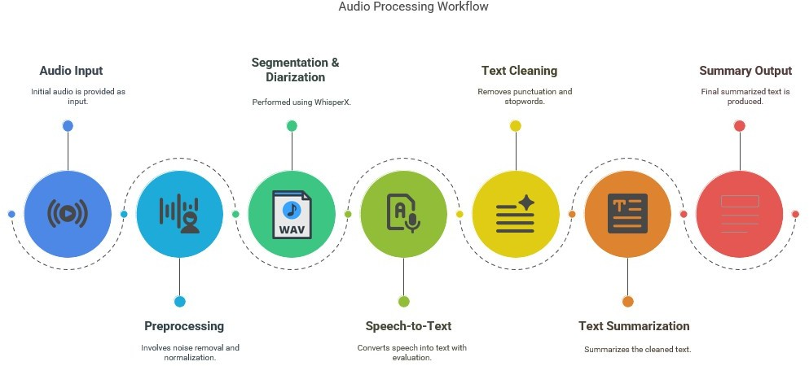

Figure 2: Software Workflow diagram

The workflow begins with audio input and ended with the audio's initial version for the system and a subsequent input. The next stage is the Preprocessing stage where both noise and recording levels are taken care of. Following this, Segmentation & Diarization is performed—typically using WhisperX—to divide the audio into segments and distinguish between different speakers. In the Speech-to-Text phase, the segmented audio is converted into text with appropriate evaluation. The resulting transcription then undergoes Text Cleaning, where punctuation and stopwords are removed to produce a refined version of the text. This cleaned text is then passed through the Text Summarization process, which condenses it into a more concise form. The final stage is the Summary Output, where the complete summarized text is produced and presented.

5. DESCRIPTION

After observing these problems faced by individuals with memory and the individuals like professials and students who has to consumer large amount of audio based data everyday, we decided to develop a system for effective processing of the audio data and generate text summaries so that the individuals and easily get gist of the happenings of the day. The Arduino serves as the central processing unit of the recording system. It receives the audio signals from the MAX9814 Electret Microphone Module. The Arduino processes this audio signal and saves the audio file along with the timestamp generated by the RTC into the Micro SD Card which is accessed thorough Micro SD Card Reader module connected to the Arduino Nano (ATmega328P). The user then put this Micro SD Card into their system and the software we have developed, using Open Source Maching learning and NLP model processes the audio present in the Micro SD Card. The Micro SD Card is FAT32 formatted which give it abilty to work with any operating system.
The software as mentioned consists of three main models which are Speaker Diarization, Speech Recognition Model and Text Summarization Model. These models works sequentially in the aforementioned order. The Speaker Diarization Model Breaks the audio into the segments if there are more than one speaker present in audio data (this is possible in sceanario such as meetings and interviews); the process is done in memory. The Speech Recognition Model then transcribe this segmented data in the sequential format based on timestamping. The transcribed data which is currently in text format is stored for the user to read in detail, along with this the text data is also fed into the Text Summarization Model to generate a concise and meaningful summaries while maitaining the context awareness. This summarised data is then presented to user with the aim of helping them remember their daily conversations to improve their productivity.

6. CLAIMS

1. An audio recording and storage system, comprising:
a microphone module (MAX9814) for capturing speech input with automatic gain control (AGC);
a microcontroller (Arduino Nano) for processing audio signals and managing data acquisition;
a real-time clock (DS1302 RTC) for timestamping speech recordings; and
a storage module (Micro SD card) for storing transcriptions and summaries.
2. A method for converting speech to text and generating text summaries, comprising:
capturing speech input via a microphone module;
preprocessing audio using noise reduction and segmentation techniques;
converting speech to text using an automatic speech recognition (ASR) model based on Transformers; and
applying text summarization models to generate summaries.
3. The system as claimed in claim 1, wherein the system processes audio signals to digital audio and stores the audio file in the Micro SD card.
4. The system in claim 1 allows users to begin and end recordings at their own discretion. In addition, the timestamp for when the recording starts is saved as the file name.
5. The method as claimed in claim 2, wherein the summarization process includes abstractive techniques, utilizing pre-trained models fine-tuned for speech-based text summarization.
6. The method as claimed in claim 2, wherein transcriptions are automatically segmented and summarized based on the number of speakers.
7. The method as claimed in claim 2, wherein the speech recognition system filters background noise and enhances speech clarity using noise reduction techniques.

7. ABSTRACT OF THE INVENTION

Speak2Summarise
The hardware-software integrated system called Speak2Summarise combines speech-to-text (STT) and text summarization. It captures spoken words and generates context-aware summaries with relatively high accuracy. Recall and content retention pertaining to memory transcription pose significant challenges. This is of particular importance to people suffering from memory-related disorders. The invention includes a hardware component consisting of a MAX9814 microphone for speech capturing, Arduino Nano (ATmega328P) for processing audio signals and saving the .wav file in sdcard, a DS1302 Real Time Clock (RTC) for time stamping the time of audio capture start time, and an SD card module for retaining the recorded audio. The provided power management subsystem operates successfully for portable and embedded applications. The system incorporates advanced features like WhisperX for ASR which ensure high accuracy speech to text conversion over the cloud. The system provides adaptations for English and extends its reach beyond assistive technologies and virtual assistance, such as business transcriptions and education. Abstract summarization methods using BERT are used to attain relevant summaries which are devoid of redundancy and provide clarity.
FIGURE: 1, 2

8. DATE AND SIGNATURE (to be given at the end of last page of specification).

